Welcome to the Touchscreen-based Behavioral Evaluation System (TBES)

We refer to TBES as a system because it requires, at a minimum, two components: a Mac Store App (Apple, Cupertino, California) and a software program written in a language using TCP/IP sockets to communicate with the TBES APP. The TBES App can be downloaded from the Mac Store free-of-charge. An information sheet, much like this one, is available with information on the inner workings of the App. This information sheet describes the installation process and some of the features of the Microsoft Visual Basic 6.0 (Microsoft, Redmond, WA) program that is also available free-of-charge. TBES is designed to serve as a visual interface for commonly used cognitive and behavioral tasks. It is the hope that this system will facilitate research and broaden our understanding of the processes that underlie visual learning and working memory.
INSTALLATION NOTES
- If you haven’t already, Unzip the “TBESVB6 Install Folder” by right clicking on the folder and clicking “Extract All”
- Open the “TBESVB6 Install Folder” and run “setup.exe”
- The Setup program will automatically create a folder on your c:\ called “TBESVB6”. If you prefer, you can select another destination folder during the installation process.
- Go to the folder “c:\TBESVB6” and run “TBES APP.exe”
- Verify that the checkbox next to “Click to run without hardware” is checked*.
  - This will allow you to run the app and collect data without activating any external hardware.*
  - This will also give you labels with real-time information about what’s happening on different trial types. See the next page for a description of the phases and trial types.
- If connecting to an iPad, verify that the box next to “iPad Connect” is green. If the box is red, then tap the iPad screen with two fingers to connect. If a problem persists, verify that the port number matches that entered in the TBES iPad app settings tab. The port number can be changed in the “PortNumber.txt” file in the “TBESVB6Acc” folder.
- Click Start
- Collect Data, hooray!
- To exit the program, press “E” (you’ll find other useful keys listed below)
Continue to the next page for more info
Additional Info:

Q: Where are the data from the session stored?
A: Data from each session are stored in two places, both within the “c:\TBESVB6Acc\Results” folder. One file provides summary info collapsed across the entire session (Results_Summary.xls), whereas, the other contains response data for each trial in a session.

Q: How do I add subject names to the drop-down menu at start up?
A:
- Open the “CurrentSchedule.txt” file in “c:\TBESVB6Acc”. The program will automatically populate the subject drop-down menu with these names. List one name per line. Alternatively, you can always add a new subject at run-time by clicking the “Enter Subject Name” box.
- If you add a subject, you need to create a file with that subject’s name in the “Parameters” folder of “c:\TBESVB6Acc”. This will allow you customize the trial, session, and stimulus parameters for each subject. We recommend you copy “Testoffice.xls” to use as a template for the new subject.

Q: How do I change the trial, session, or stimulus parameters for a subject?
A: Go to the subject’s file in the “Parameters” folder within the “TBESVB6Acc” folder. Adjust the values as needed. These changes can be saved and will be represented at run-time. This allows you customize the trial, session, and stimulus parameters for each subject.

Q: How do I change the images used during a session?
A: At present, the “Image” folder is only for displaying the images on the computer. The iPad has its own image bank and, at present, these images cannot be changed. Look for this feature to be updated in TBES Version 2.0.

Q: What are the keys useful for changing conditions during a session?
A: The following keys will have the described effects at run-time.
"E" End the session at any time and bring up the save data screen.

"F" Freeze stimulus - the stimulus will not timeout after the specified duration.

"R" Resume trials - Erases the current stimuli and resumes the trials to session-startup parameters

"L" Lengthen the stimulus interval in real-time by 1000 ms

"I" Alters the session to count a trial as correct ONLY if a response is made while the stimulus is displayed.

"P" Alters the session to count a trial as correct ONLY at the end of the stimulus duration.

“B” Alters the session to count a trial as correct BOTH at the end of the stimulus duration and with a response, whichever comes first.
This program has been tested with Med-Associates equipment and scripts written in Visual Basic 6.0. More information on the App, as well as procedures appropriate for the device can be found in recent publications by Leising, K.J (http://tinyurl.com/KenLeising).
The VB program assumes an iPad screen that is divided into six Sections and each Section can display a visual stimulus. Sections are tagged by the number 1-6.
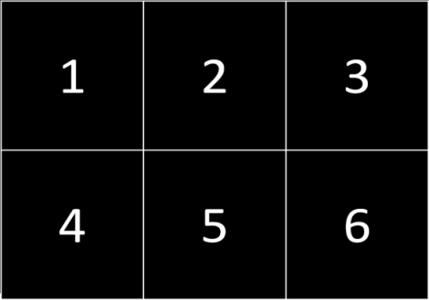
The Visual Basic program also assumes the following images (which have been preloaded with the Mac App) have been assigned a unique single-digit numeral from 1 to 7 by the TBES App.
1 2 3 4 5 6 7

- The Visual Basic program will place the specified Image on the display, in the same order as the Sections.
- When the section is touched, the App returns the Section tag and the VB program determine whether the image in this section is correct or not.

The script is capable of running the following training programs:
- Magazine Training – A signal to raise a dipper is delivered every 60s and the dipper waits for a signal from an infrared detector to initiate a 3-s access period before lowering the dipper. The waiting feature can be turned off using the subject’s parameter file. No visual stimuli are presented.

- Autoshaping – a 5.53 cm grey circle will be displayed in Position 2 for 10 seconds (s) followed by a reward delivery command. A touch to the circle will also issue a reward delivery command. Each reward is followed by ~60 s before the grey circle reappears. There are 30 trials per session. This number of trials, ITI, stimulus duration, and reward duration can be changed using the subject’s parameter file.
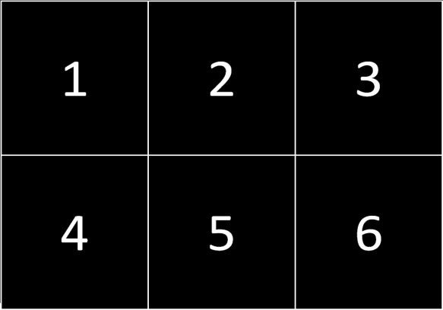
- Successive discrimination – from the set of six 5.53 cm images shown above, the images are divided into two categories. In one category (S+), a touch to the image results in reward delivery. Touches to images in the second category (S-), result in a 10-s timeout period with no stimuli. If no response is made to the S-, then the trial times out delivered after 15 s. There is a 20-s ITI between all trials. There are 84 trials per session (14-trials per stimulus).
- Simultaneous discrimination – The same six stimuli are used, however, each S+ is paired with an S- and presented simultaneously on the screen in positions 1 and 3, randomized across trials. Trials end only if a response to the S+ is made. Responses to the S- are recorded but do not result in any observable effects. Each reward is followed by 20 s ITI and then a new trial begins. There are 84-trials per session (28 trials per pair).

