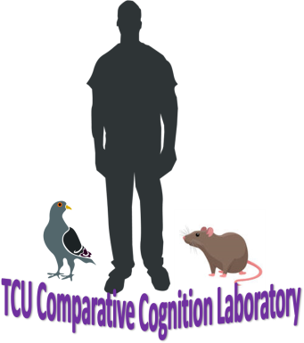
Application for TCU Comparative Cognition Laboratory
Summary
Our focus is on the ability of human and non-human animals to learn through experience the predictive value of the stimuli (e.g., temporal, spatial, and causal) that surround them. For example, how can you predict when your next meal will be? It will likely have to do with multiple stimuli, including the time of day, internal hunger signals, how much money you have, and the availability of your friends. Several goals unite pigeons, rats, and people. Finding food and willing mates, and avoiding dangers are some of them. In the free-roaming animal, the stimuli which predict these events are accompanied by the color, smell, sight, sound, and taste of other animals, places, and things around them. In the laboratory, these stimuli are often simplified to the color, sight, or sound of incandescent lights, digital noises, and digital images. Utilizing a comparative approach, in which an experimental procedure is used with more than one species, allows for a more comprehensive answer to the questions of what stimuli animals use to predict these events, and how much value a single stimulus can communicate (e.g., where food is available, when food is available, and what response is required to get food). Visit tcucomparativecognition for more info.
In the lab, you will be expected to:
- handle pigeons
- handle rats
- instruct human participants
- spend 10 hours per week engaged in research-related activities in the laboratory
The best predictors of success as a research assistant are:
- commitment – are you prepared to show up on time week to week?
- interest – is this area of research truly interesting to you? I have no doubt this experience will facilitate your personal and professional growth. Past research assistants have gone from my lab to Experimental Psychology graduate programs, Clinical and Counseling graduate programs, Teach for America, Physical Therapy doctorate programs, Law School, and more. This area of research doesn’t have to be your long-term goal, but in the short term it should be something that interests you.
- respect for the value of animal research – are you morally okay with the use of animals in research? I have had students across the spectrum participate in my lab. Students who are concerned about the health and wellness of the animals will find the laboratory a rewarding place to do research. You will find that we demonstrate respect for our animals, and we expect that you will do the same.
About you
Name:

Major:

Total Hours of Psychology courses taken:

Classification (we require a minimum of two semesters as a research assistant):

Are you an honor’s student:

Cumulative GPA:

Psych GPA:

Post-graduation plans:

I have found that commitment, openness to animal research, and motivation (e.g., to learn, about animals, in the causes of behavior, etc.) best predict performance as a research assistant. Please comment on whether these qualities represent you, as well as what interests you about the opportunity to assist in the Comparative Cognition Laboratory?

